CSA 283: Exam Two

Name: ______________________________________ Section: _____ _____

Please write legibly. Ask questions if something is unclear. Write down any assumptions you make. Be concise in written answers. Longer is not always better.

EXAM IS PRINTED ON BOTH SIDES OF THE PAGE.

- Give definitions for the following terms using one or two sentences. If the term is includes an acronym, also state what the letters in the acronym stand for. (20 points)

a. Dual Stack in relation to IPV6:

b. Gateway router

c. Inter-AS Routing Protocol:

d. Virtual Circuit Number

- Suppose the following two segments where transmitted simultaneously:

Segment One Characteristics:
  - Source address: IP1
  - Source port 100
  - Destination address: IP3
  - Destination port 300.

- Segment Two Characteristics:
  - Source address: IP2
  - Source port 100
  - Destination address: IP3
  - Destination port 400.

    - Assuming that both packets reach their final destination and are transmitted using UDP, will the two UDP packets be received by the same socket? Why or why not? (4 points)

    - Were the two segments sent by the same computer? Explain your answer. (4 points)

    - Would it be possible for these two segments to have been transmitted using TCP? Why or why not? If it is possible, would the two segments be received by the same socket? (4 points)

- The receive window for Host B to which the host A is sending data is 13,000 bytes. Host A has transmitted 5,000 bytes of data. 2,000 of these bytes have been acknowledged. What is the maximum number of bytes Host A can transmit to Host B at this time and stay within the window? Explain/show your reasoning. (4 points)

- A block of data for transmission using the TCP protocol has been broken up for transmission into four separate segments.
- The sequence number of the first segment is 1500.
- The first segment contains 400 bytes.
- The second segment contains 300 bytes.
- The third segment contains 200 bytes
- The fourth segment contains 100 bytes

- Complete the following table by writing the correct sequence number for each segment and the sequence number that would be used by the receiver to indicate in order receipt of each segment (Nothing is lost. All arrive in order.) (8 points)

 | Segment Sequence Number | Acknowledgement Number
First Segment
Second Segment
Third Segment
Fourth Segment

Recall that TCP uses cumulative acks. Suppose that segments actually arrive at the receiving end in the following order.

Second Segment, Third segment, Fourth Segment, First segment,

- Give the TCP acknowledgement that will be sent for each segment if the receiver is using a Go-Back-N protocol. (6 points)

_______ ACK when Third segment arrives

_______ ACK when Fourth segment arrives

_______ ACK when First Segment arrives

_______ ACK when Second Segment arrives

- Give the TCP acknowledgement that will be sent for each segment if the receiver is using a Selective-Repeat protocol. (6 points)

_______ ACK when Third segment arrives

_______ ACK when Fourth segment arrives

_______ ACK when First Segment arrives

_______ ACK when Second Segment arrives
- What is flow control? Why is it important? Be concise. (4 points)

- Figure 1 is a simplified network diagram. The network includes three hosts (A, B, and C) and one router. The router is performing Network Address Translation (NAT) using the NAT table below the figure. Host Z with an IP address of 132.53.130.69 has received a datagram on a socket with a local port number of 80. The received datagram was originally sent by host B using a socket with a port number of 3200. 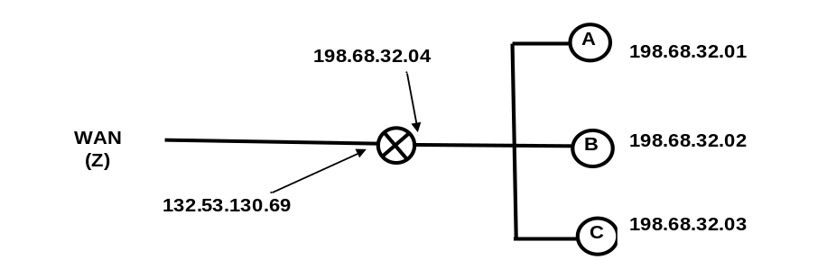
Figure 1: Simple Network with a Router Using the NAT Protocol
NAT Translation Table
WAN side address | LAN side address
132.53.130.69, 4000 | 198.68.32.01, 2000
132.53.130.69, 3500 | 198.68.32.01, 2500
132.53.130.69, 3000 | 198.68.32.02, 3200
132.53.130.69, 2800 | 198.68.32.03, 3200
… | …
Fill in the source and destination IP addresses and port numbers for the datagram that carries a reply from Z back to B. (10 points)

 | From Z to router | From router to B
Source IP
Source Port
Dest. IP
Dest. Port

- TCP congestion control uses the number of duplicate acks and timeouts to determine the transmission rate. Assume the following events:

- Transmission of data begins at time 0 (RTT 0) with a congestion window size equal to 1 MSS (Maximum Segment Size).
- A timeout event occurs between RTT 3 and RTT 4.
- Three duplicates acks are received between RTT 7 and RTT 8.
- Positive acks received during all other RTT intervals

Write the size of the congestion window and the threshold for each RTT period in terms of MSS. The CongWin should be adjusted at the end of each RTT interval based on what happens in the interval. (10 points)

Time | Size of congestion Window (CongWin) in Maximum Segment Sizes (MSS) | Threshold in MSS
0 RTT | 1 | ∞
1 RTT
2 RTT
3 RTT
4 RTT*
5 RTT
6 RTT
7 RTT
8 RTT*
9 RTT
10 RTT
- Below is a portion of a routing table.

Prefix | Link Interface
11001111 00010011 1001 | 0
11001111 00010011 10011001 | 1
11001011 00010111 00011 | 2
Otherwise | 3

- Give the Classless InterDomain Routing (CIDR) notation for the subnets identified by the second row of the table (for example 200.23.16.0/23). Indicate approximately how many hosts each sub-net could contain. (4 points)

CIDR notation Approx. Number of Hosts

________________________ __________

- Using the destination IP addresses, determine which link interface each of the following packets should be sent to. (6 points)

Destination IP Address | Link Interface
11001111 00010011 10010001 11011101
11001111 00010101 00011000 10101101
11001111 00010011 10011011 00011000

- Fast retransmit occurs after a three duplicate acks in order to avoid an extended delay before resending a lost packet. (2 points)

TRUE FALSE

- TCP uses network assistance for congestion control. (2 points)

TRUE FALSE

- The UDP protocol uses a three way handshake to establish a connection.
(2 points)

TRUE FALSE

- Using node A in Figure 2 as the source, show the step by step results of link state (LV) algorithm to find the shortest path to all other nodes. Show the members of N, the predecessor of each destination, and the shortest known distance to each destination after the initialization phase of the algorithm and after each iteration of the main loop.
(12 points)
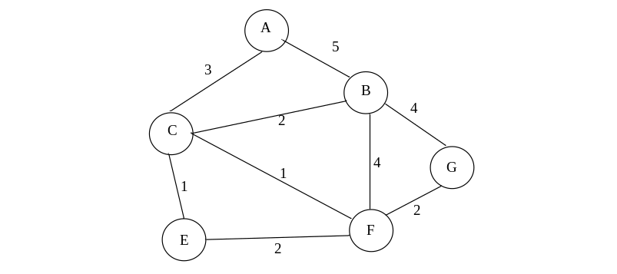
Figure 2: Network Graph

- Write down the shortest path to all destinations in Figure 2 using the predecessor data in the table you created in the previous question. In other words drawn the minimum spanning tree (MST). (7 points)

- Consider the following transport and network layer protocols. Place Xs in the following table to indicate which mechanism is applicable to each protocol. If a mechanism is not applicable to the protocol leave the cell blank. (9 points)

 | Mechanism
Protocol | Sequence  Numbers | Timers(s) | Checksums
UDP
TCP
IP

- Assume numerous pipelined segments when answering the following questions.(8 points)

- What mechanism is used to detect corrupt packets? (circle the appropriate mechanism(s))

Sequence Numbers Timer(s) Checksums

- What mechanism is used to detect duplicate packets? (circle the appropriate mechanism(s))

Sequence Numbers Timer(s) Checksums

- What mechanism is used to detect lost packets? (circle the appropriate mechanism(s))

Sequence Numbers Timer(s) Checksums

- What mechanism is used to detect out of order packets? (circle the appropriate mechanism(s))

Sequence Numbers Timer(s) Checksums

